**IOT BASED PATIENT HEALTH MONITORING SYSTEM**

* **ABSTRACT**
* Improving efficiency in the healthcare sector is one of the difficult and most challenging jobs. That includes various aspects such as getting an ambulance within a minimum amount of time, providing proper treatment to the patient in time so that the chance of surviving increases in critical condition.

The idea here is to provide an intelligent smart health monitoring system using some sensors and ATmega328P. The system aim is to design a device in which sensors will sense the heartbeat, blood pressure, glucose level and oxygen-level of the human body.

* After sensing, sensors will send respective data to the ATmega328P. After that ATmega328P will analyse and sent it to the internet or IoT cloud thought to get the way. In the collaborated hospital the patient’s data will be sent through the internet. In the hospital, the respective doctor will continuously monitor the patient’s health system.
* The patient's data and all history can be accessed by the doctor

before the patient reaches the hospital. Sending the patient’s

health information to the hospitals helps the hospital staff to get

things ready required for the treatment.

* The main purpose is to design communication between the

Patient Health Status and the monitoring station.

* **LITERATURE SURVEY**
* Ananda Mohan Ghosh has proposed a health monitoring system for managing the hospital to allow family members and consultant doctors to remotely monitoring the patient's health condition through the internet with E-health sensor shield kit interface kit. But it does not send any notification such as email and SMS alert to the respective

family members and doctors.

* P Kumar has proposed a patient monitoring healthcare system which is controlled by a raspberry pi such as the heartbeat rate, respiration level, and temperature and body movement of the patient is monitored and data is collected by using sensors and displayed it on the screen

using the putty software. However, it does not provide the alarm notification for insisting the family members or doctors give the prescribed drugs to the patient which is included in our proposed solution.

* Sarfraz Fayaz Khan has demonstrated a useful patient’s

healthcare monitoring system with the help of IoT and RFID

tags. But, it does not contain preventive measures concerning

the patient health condition by controlling the appliances and

providing the prescribed drugs to the patient which is

included in our paper.

* Freddy Jimenez have considered only on monitoring

the patient’s health condition and sending the necessary

information and notification to doctors, family members.

Moreover, it does not contain the appliance control, which is

included in our project; it only focused on Monitoring and

provides notification to the respective people on time.

* S. Siva has demonstrated to monitor a patient’s

health condition by using the smart hospital system. The

health condition of the patients can be monitored by using the

spark kit. It gathers information about the temperature and

heartbeat rate of the patient and sent an alert notification if

any of the obtained parameters crosses the predefined

threshold value.

* Our proposed solution is divided into three basic parts

1. Sensor Modules

2. Microcontroller and Wi-Fi Module

3. IoT Server

* **Sensor Modules**

*1. ECG Module*

The AD8232 is an integrated signal conditioning block for

ECG and other bio-potential measurement uses. It is designed

to sense, amplify, and filter small bio-potential signals in the

presence of noisy conditions, such as those created by motion

or remote electrode placement.

*2. Pulse Oximeter*

The MAX30100 is integrated pulse oximetry and a heart-rate

monitor module. It consists of internal LEDs, photodetectors,

optical elements, and low-noise electronics with ambient light

rejection. The MAX30100 gives a complete system solution

to ease the design-in process for mobile and wearable devices.

*3. Temperature Sensor*

LM35 is a temperature sensor used to sense the temperature it

works on the principle of Peltier effect. Its accuracy is +/-

0.4℃ which is much more than a thermistor.

*4. Glucometer*

*5. Blood Pressure Sensor*

Blood pressure is the pressure of the blood in the walls of

arteries as it is pumped around the body by the heart. When

your heart beats, it contracts and circulates blood through the

arteries to the rest of your body. This force creates pressure on

the arteries. Blood pressure is recorded as two types the

systolic pressure (as the heart beats) over the diastolic pressure

(as the heart relaxes between beats).

* **Micro-controller and Wifi Module**

In our model in used ATmega328P as a micro-controller and

ESP8266 is used as Wi-Fi Module. All the raw data of

sensors are collected by ATmega328P then it compares with

the reference value and gives an alert message in the display.

Here the Data is transferred serially to Node-mcu which has

ESP8266 Wi-Fi Module receives the values and transmits

wirelessly to IoT platform.

* **IoT Server**

Internet of Things (IoT) is defined by many people but in

simple words, IoT is nothing but some devices that connect

and interact using the internet. In this project, we are using

ThingSpeak IoT platform. ThingSpeak is an IoT platform and

API for data collection and analytics. It serves as a bridge

connecting edge node devices, such as temperature and

pressure sensors that collect data and data investigating

analysis software that analyzes the data.

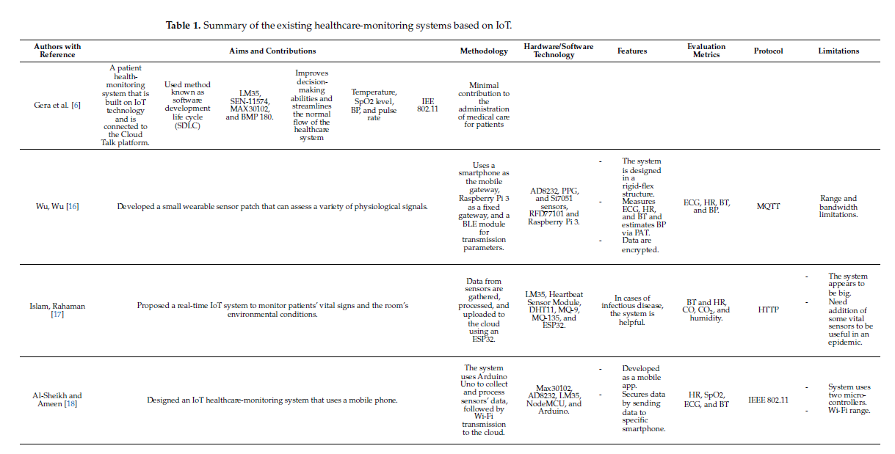

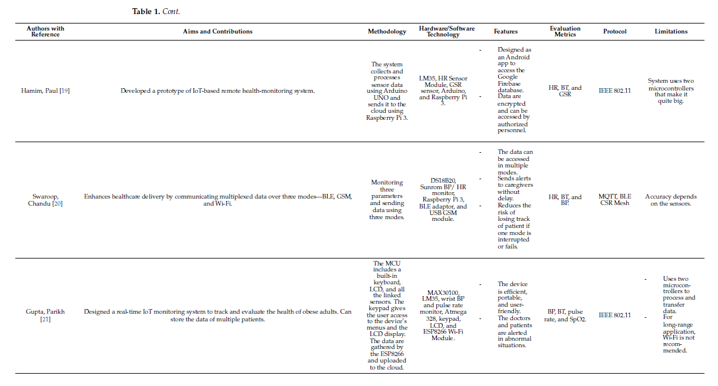

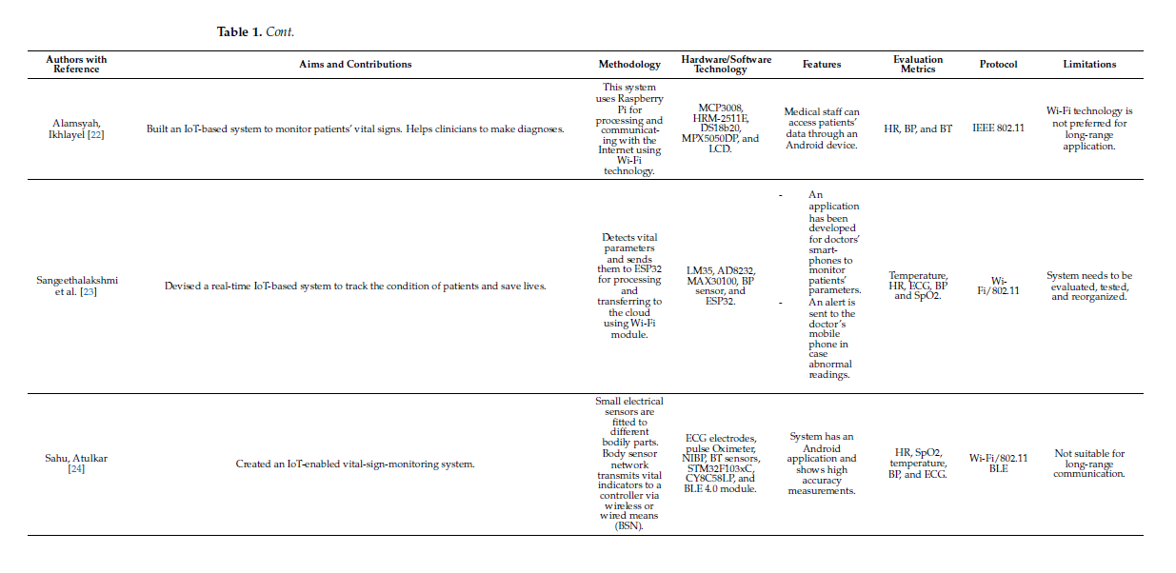

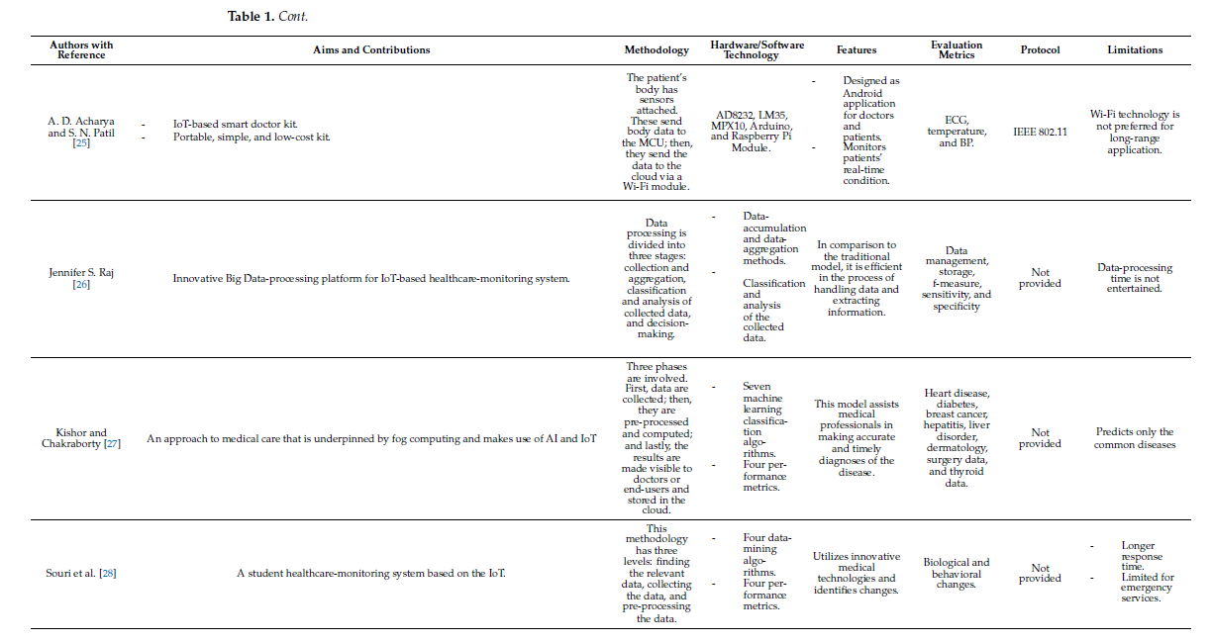

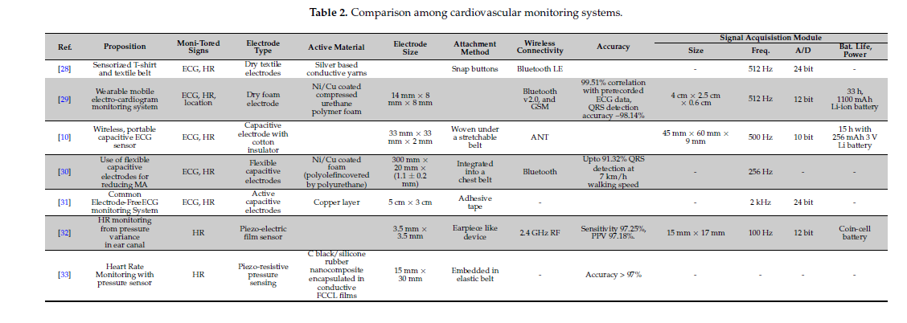

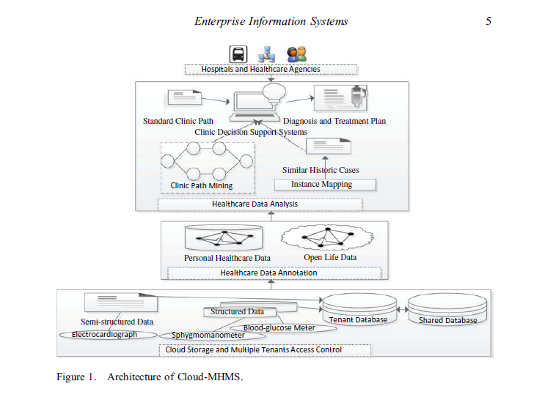

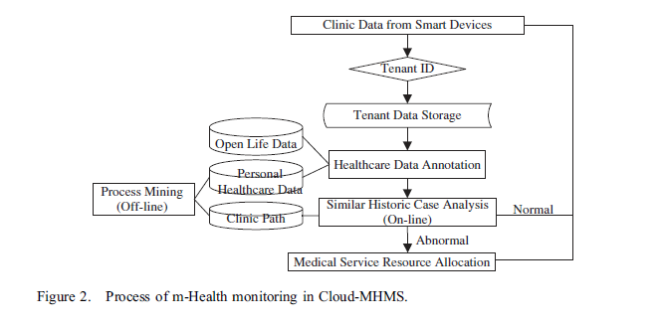

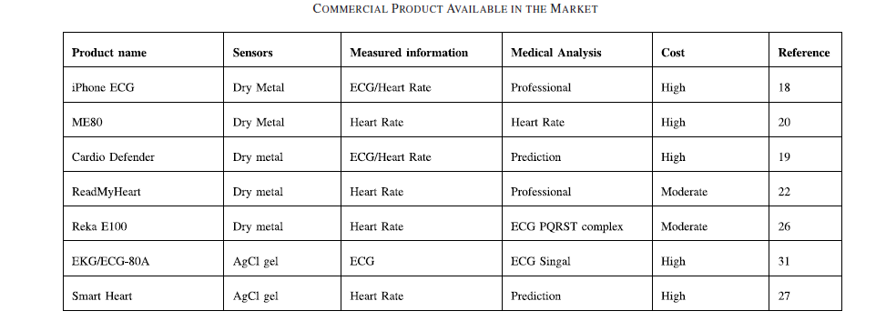

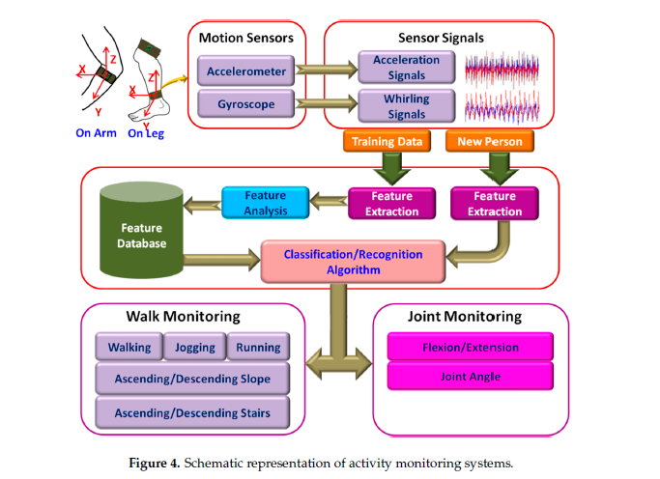

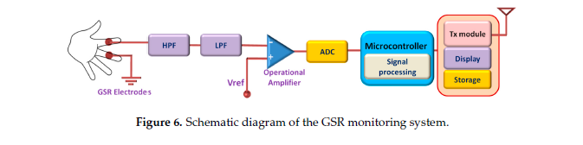

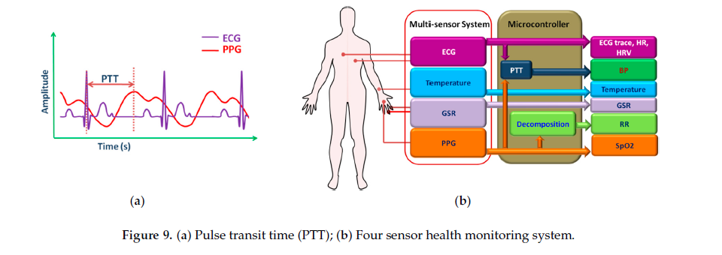

* **MONITORED DATA**

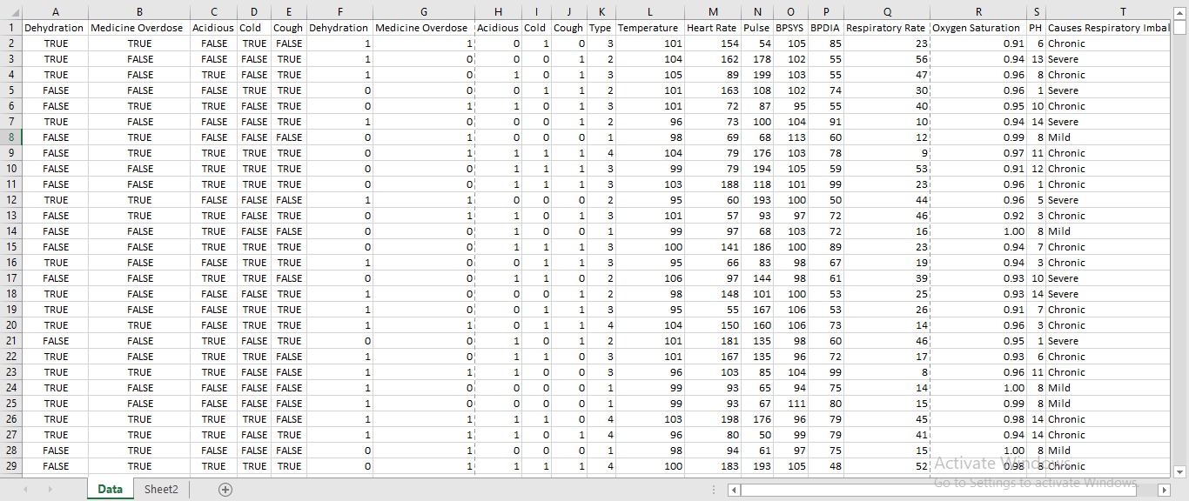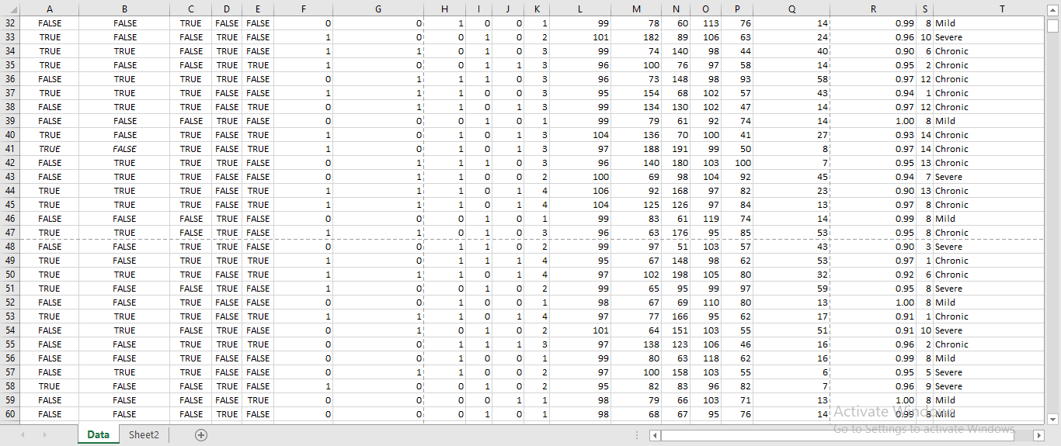

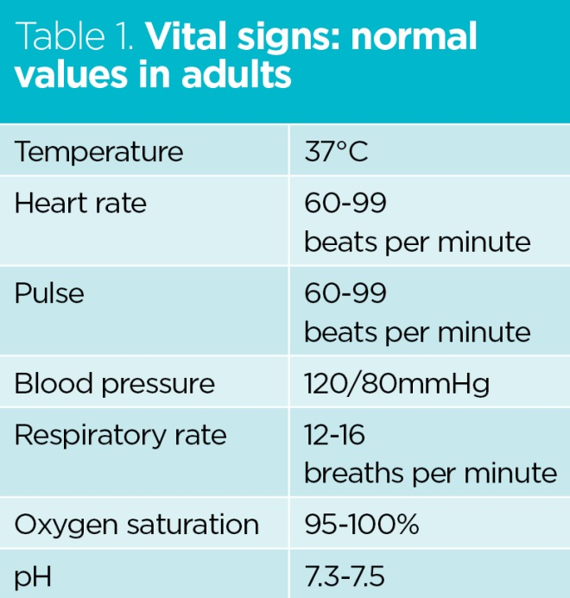

* **REVIEWS**

Apollo Hospitals (India): Apollo integrates IoT-based systems in telehealth and remote patient care. They use wearable devices to monitor vital signs like heart rate and blood pressure, enabling timely interventions. These systems typically achieve accuracy rates above 90% depending on the device used.

* **CONCLUSION**

By taking into account immense practical importance of IoT based live monitoring system for patients with the risk of heart attack, uneven accidents and emergency cases, a simple lowcost health monitoring scheme is presented in this Project.

ATmega328P is used for this application because of its multitasking capability and low power consumption.